**Atmospheric Water Generator**

Authors: Nooman Khan, Sarfraz Khan, Qais Khorajiya, Jamdar Sairan, Prof. M.A. Gulbarga

DOI Link: <https://doi.org/10.22214/ijraset.2022.41406>

Certificate: [View Certificate](https://www.ijraset.com/print-certificate/atmospheric-water-generator)

**Abstract**

An Atmospheric Water Generator is a device which is extracts water vapor from the humid air. By using different dehumidification technique. the water vapor accumulated then water is then filtered and purified through several filters including carbon, and reverse osmosis, and UV sterilization lights. The result is pure drinking water from the air. an Atmospheric Water Generator Works on the same principle as a refrigerators and air conditioners i.e on the principle of vapor compression refrigeration. in atmospheric water generator air passing through evaporator coil which temperature maintain below dew point temperature of water by vapour compression refrigeration method air condenses to to dew point temperature water vapor separate from air then collected water vapor is passed through a filtration system and it is then stored in a tank. The major aim or objective of our project is to provide safe and clean drinking water to those areas which are facing water shortage problems or where water transportation through regular means is expensive (especially rural areas). Our project hopes to reduce this problem by providing an atmospheric water generator that will run via bicycle-gear arrangement or stand-alone renewable source of energy i.e either solar or wind.

**Introduction**

**I. INTRODUCTION**

Water is indispensable for human life and the development of industry and civilization. Water resources however are rapidly declining due to the gradually increasing human population, industrial pollution and inappropriate agricultural policies found that two-thirds of the global population (4.0 billion people) live under conditions of severe water scarcity at least one month per year. Half a billion people in the world face severe water scarcity all year round. Even though in other rich water resource areas it is still difficult for hikers. Because of pure water scarcity in many regions worldwide. Finding alternative methods for pure water generations because At any instant of time the earth’s atmosphere contains 37.5 million billiongallon of water vapour if these water is condense enough to cover Entire atmosphere surface with 1 inch of rain.

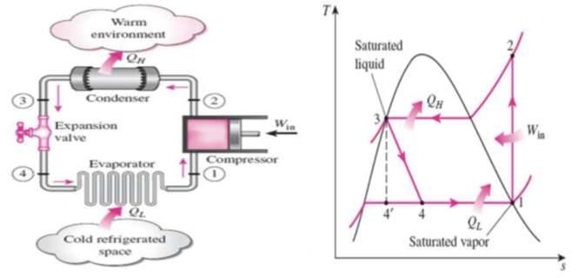

This is enough to motivate many research to work on related topic AWG (ATMOSPHERIC WATERGENERATOR) one of the promising device to condense the water vapour present in atmosphere for this purpose the project group will initially investigate the suitability of the vapor-compression cycle, where the extraction will be obtained on the evaporator. An AWG is a device that generates clean drinking water by utilizing the natural presence of water vapor in the air. This thesis will hopefully result in information that will be used as a basic data for decision-making. Since most of the evaporators on the market today are designed merely to cool the air passing through them, much effort will be made to design an evaporator that not only lower the temperature but also condensate some of the water vapor included in the air and to collect the condensed water if this technology is assessed to be liable. There can also be other technologies that can be more suitable for this application. The main purpose is to investigate which technology is the most suitable one in order to extract water. Other possible solutions for this problem will be presented, explained and discussed. The purpose is to find and develop a technology applicable for water extraction.

We developed several goals that the design should be able to meet.

They are-

1. Flexibility in Power Source - The design should be able to utilize a variety of power sources, including (but not limited to) solar, wind, and the traditional power grid.
2. Maximize Efficiency - The design should maximize the water produced per unit energy.
3. Minimize Cost - The design should minimize the cost per unit water production for both capital cost and production cost.

**II. LITERATURE REVIEW**

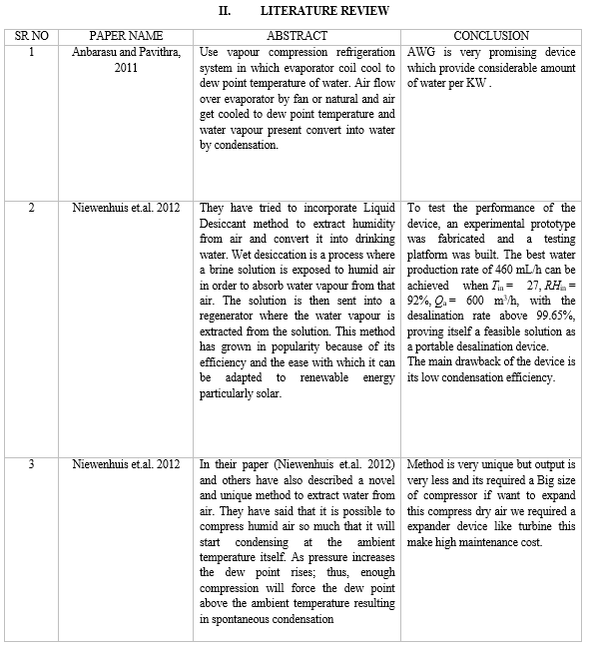

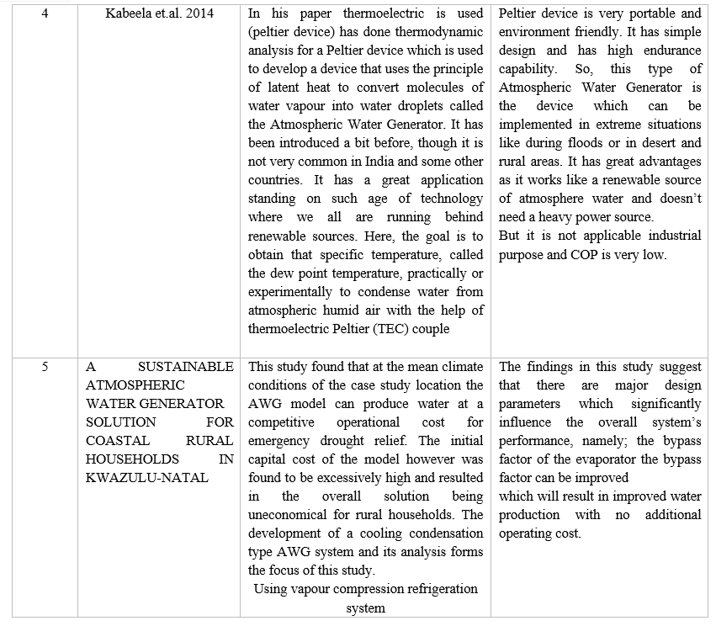

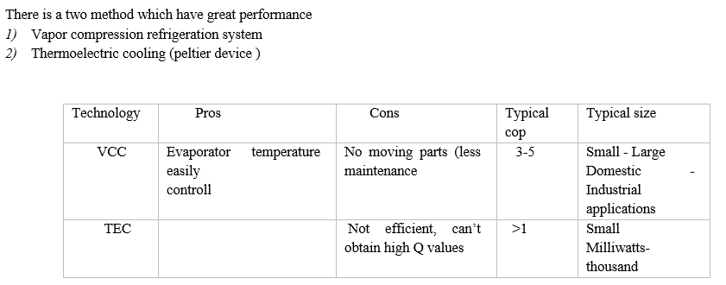

**III. METHODOLOGY**

After study numbers of paper on the basis of cop and ecofriendly and easy to operate we are going to try to make atmospheric water generator by using vapour compression refrigeration system Vapor-compression refrigeration is the most widely used method for air-conditioning in today’s world. The vapor-compression consists of a circulating liquid refrigerant as the medium which absorbs and removes heat from the space to be cooled and subsequently rejects that heat to the atmosphere. Figure depicts a single-stage vapor-compression system. Basically the system has four components: a compressor, a condenser, a thermal expansion valve and an evaporator. Circulating refrigerant enters the compressor as saturated vapor and is compressed This results in high pressure which in turn is responsible for higher temperature. Thecompressed vapor then comes out as superheatedvapor and attains a temperature and pressure at which condensation can take place with the help of cooling water or cooling air. That hot vapor is passed through a condenser where it is cooled and condensed. This is liquid refrigerant known as saturated liquid is next passed through an expansion valve where there is a sudden drop in pressure. This results in the adiabatic flash evaporation of the liquid refrigerant.  As it is called lowers the temperature of the liquid and vapor refrigerant mixture which makes it colder than the temperature to be achieved (temperature of the enclosed space). The cold mixture is passed through the coils in the evaporator. A fan circulates the warm air in the enclosed space where the circulating refrigerant rejects heat from the system. The condensed across the coils carrying the cold refrigerant liquid and vapor mixture. That warm air evaporates the liquid part of the cold refrigerant and at the same time, the circulating air is cooled and as a result it lowers the temperature of the enclosed space to the temperature to be achieved. The circulating refrigerant absorbs and removes heat from the evaporator (cover by a cylindrical plate) which is then rejected in the condenser and transferred by the water or air used in the condenser. For the completion of the refrigeration cycle, the refrigerant vapor coming out of the evaporator which is again a saturated vapor is returned back into the compressor.

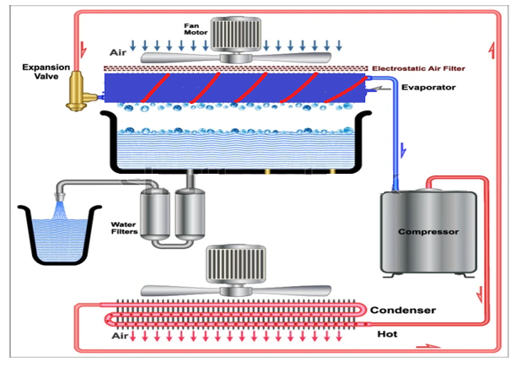

The components which make up a refrigeration system are as follows:

1. Compressor
2. Condenser
3. Receiver tank
4. Expansion / throttle valve
5. Evaporator
6. Refrigerant
7. Auxiliary components
8. Fan

*A. Calculation*

First we have calculate dew point temperature (at which vapour start condense) at different DBT (dry bulb temperature) and different relative humidity.

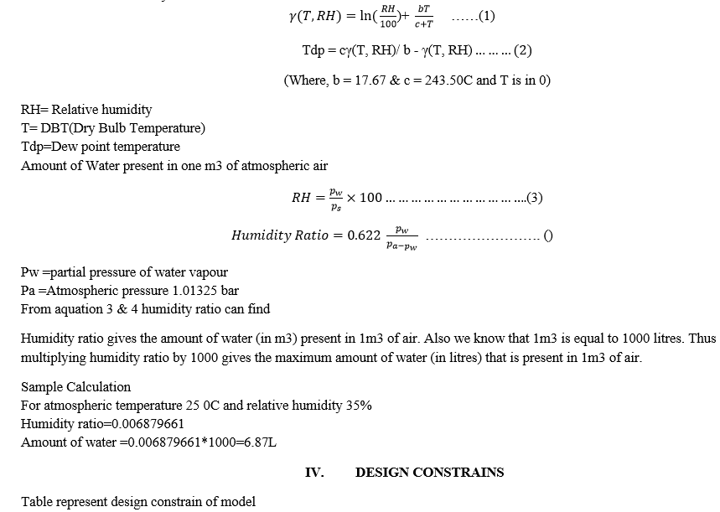

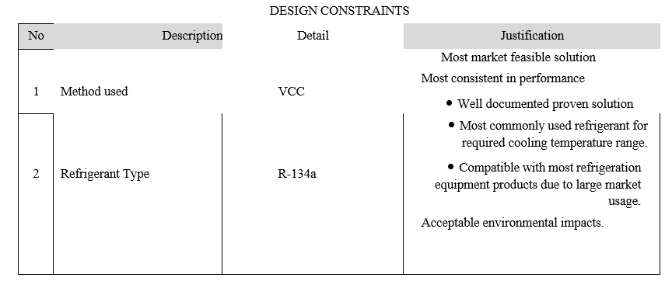

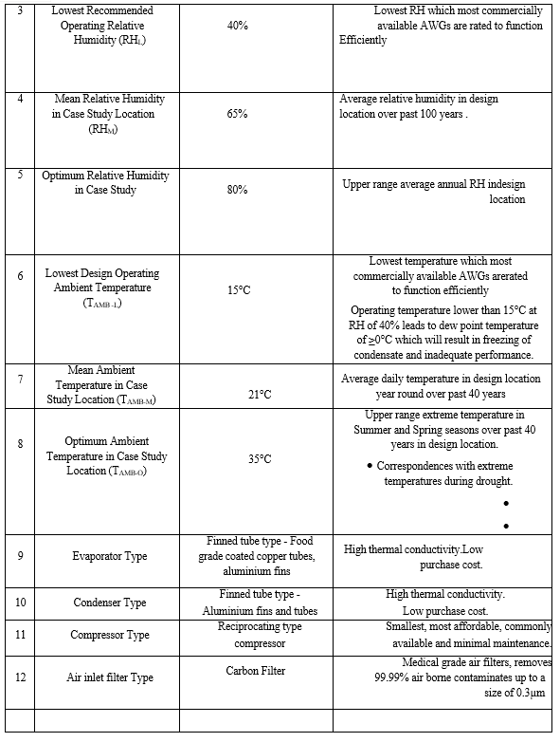

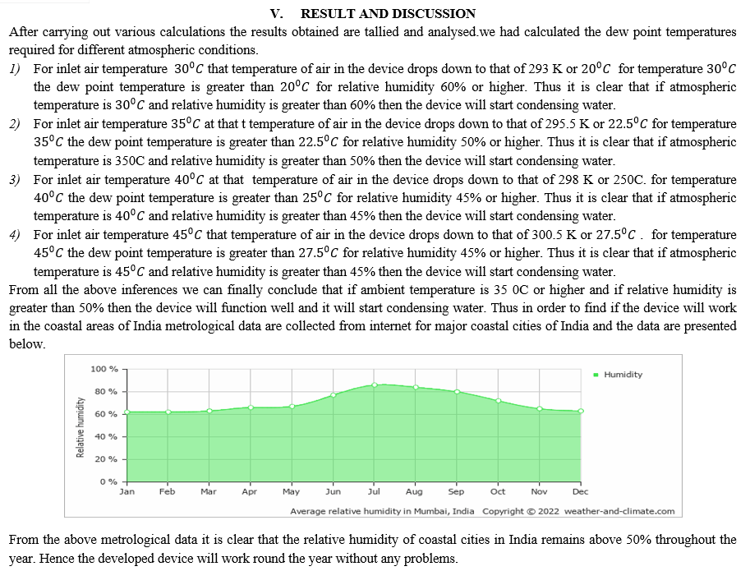

**Conclusion**

The prototype was subjected to tests at Mumbai and it was found that the water output from the device was not satisfactory. After diligent study and research we found that the following reasons may be responsible for the low water output of the device: AWG solutions can be improved by optimising the bypass factor to achieve optimum system efficiency which will result in improved water production. As such the area of evaporator coil is generally low. So we used a copper plate in contact with the cooling surface o high conductivity expecting that the cold surface area will increase thereby increasing the condensation area finally condensation is increase.

**References**

[1] Rao Y.V.C. “An Introduction to Thermodynamics” (2nd ed.). Universities Press, 2003. [2] Perry R.H and Green D.W. “Perry\'s Chemical Engineers” Handbook. McGraw-Hill, 1984 [3] Siegfried Haaf, Helmut Henrici. \"Refrigeration Technology\" in Ullmann\'s Encyclopedia of Industrial Chemistry, Wiley-VCH, 2002 [4] Dixon S.L. “Fluid Mechanics, Thermodynamics of Turbomachinery” (Third ed.). Pergamon Press, 1978 [5] “Thermoelectric Coolers Basics\". TEC Microsystems. 2013 [6] Anbarasu T., Pavithra S. “Vapour Compression Refrigeration System Generating Fresh Water from Humidity in the Air”, 2011 [7] Niewenhuis B., Shepperly C., Beek R.V., Kooten E.V. “Water generator water from air using liquid desiccant method”, 2012 [8] Kabeela A.E, Abdulazizb M., Emad M.S. “Solar-based atmospheric water generator utilisation of a fresh water recovery: A numerical study”, 2014 [9] Brown, D.R., Fernandez N., Dirks J.A., Stout T.B. \"The Prospects of Alternatives to Vapor Compression Technology for Space Cooling and Food Refrigeration Applications\". Pacific Northwest National Laboratory (PNL). U.S. Department of Energy, 2010 [10] Arora C.P, Refrigeration and air conditioning. Tata McGraw-Hill Education, 1July 2001 [11] https://eosweb.larc.nasa.gov/cgi-bin/sse/grid.cgi?email=skip@larc.nasa.goV.in

**Copyright**

Copyright © 2022 Nooman Khan, Sarfraz Khan, Qais Khorajiya, Jamdar Sairan, Prof. M.A. Gulbarga. This is an open access article distributed under the [Creative Commons Attribution License](https://creativecommons.org/licenses/by/4.0/), which permits unrestricted use, distribution, and reproduction in any medium, provided the original work is properly cited.